Second Mandatory Assignment, Algorithms and Data structures

Task 1 a)

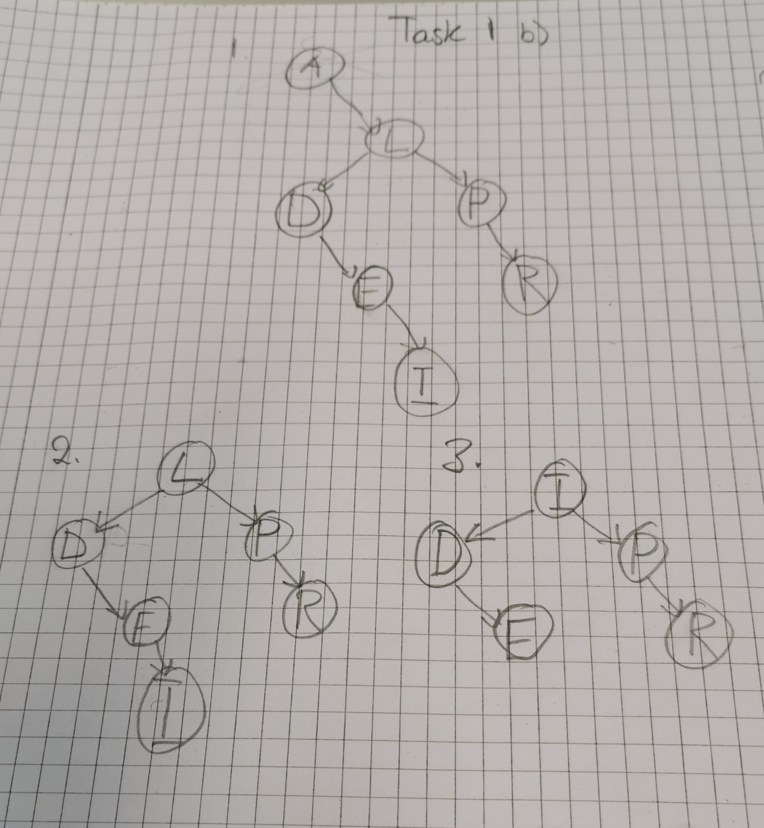Task 1 b)

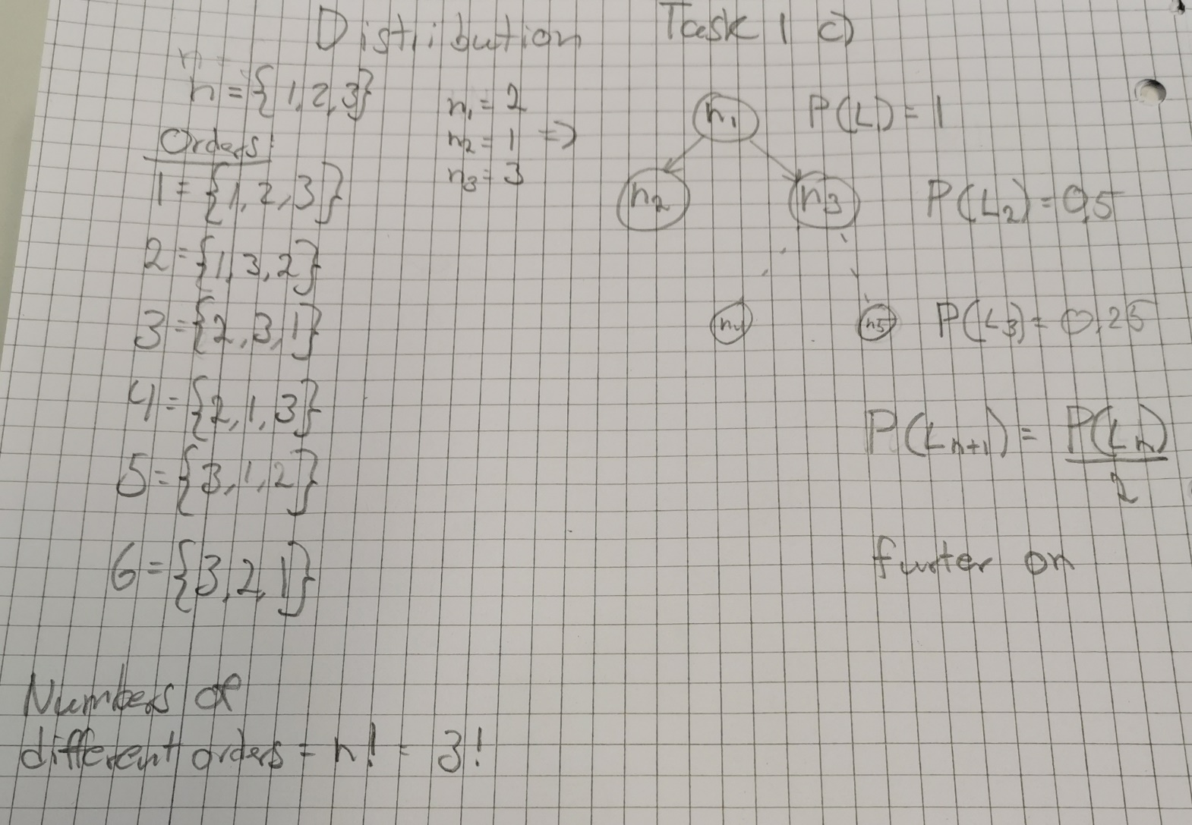Task 1 c)

Task 3 b1)

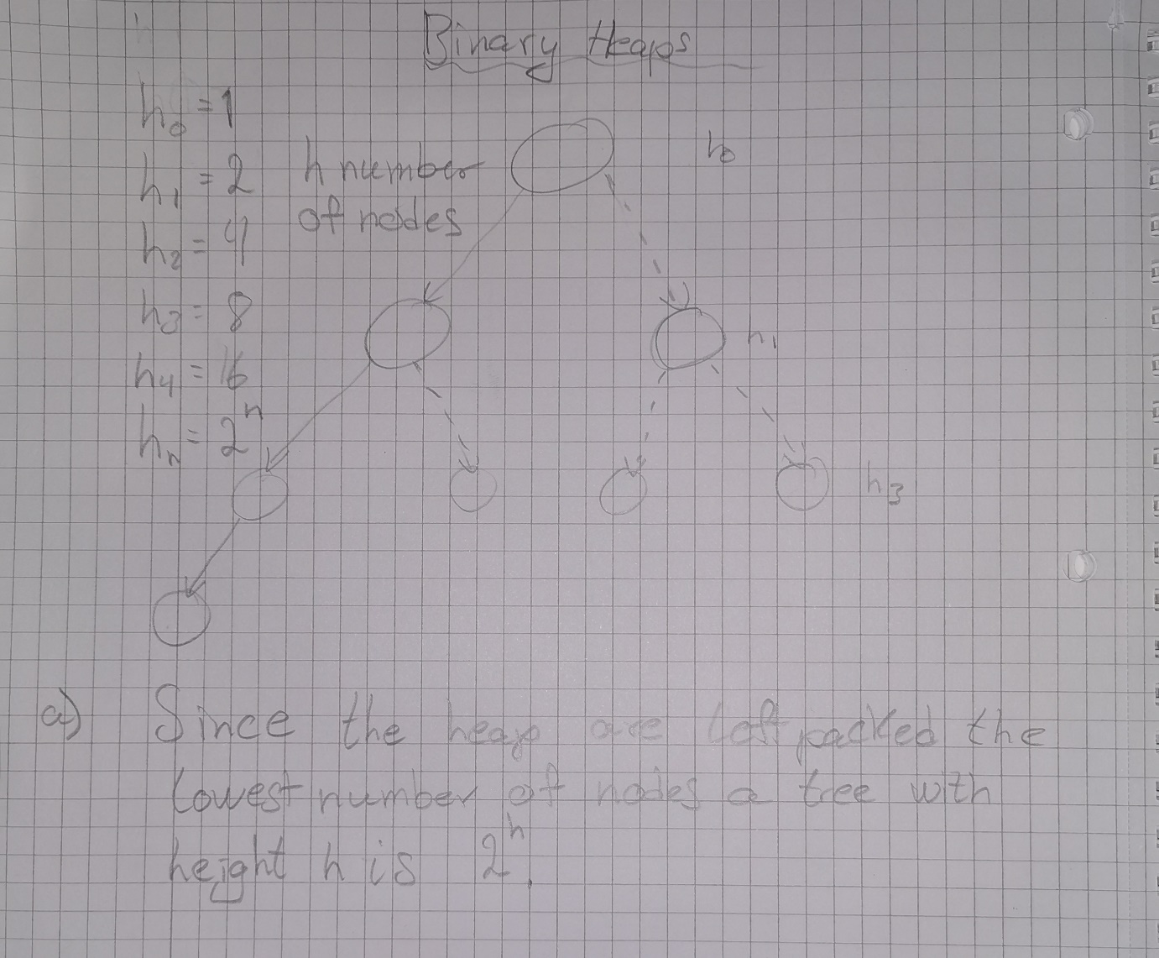

Since the heap are left packed the lowest number of nodes a tree with height h is . To achieve the lowest number of nodes, all levels must be full except the last one which has only on leaf node.

Task 3 b2)

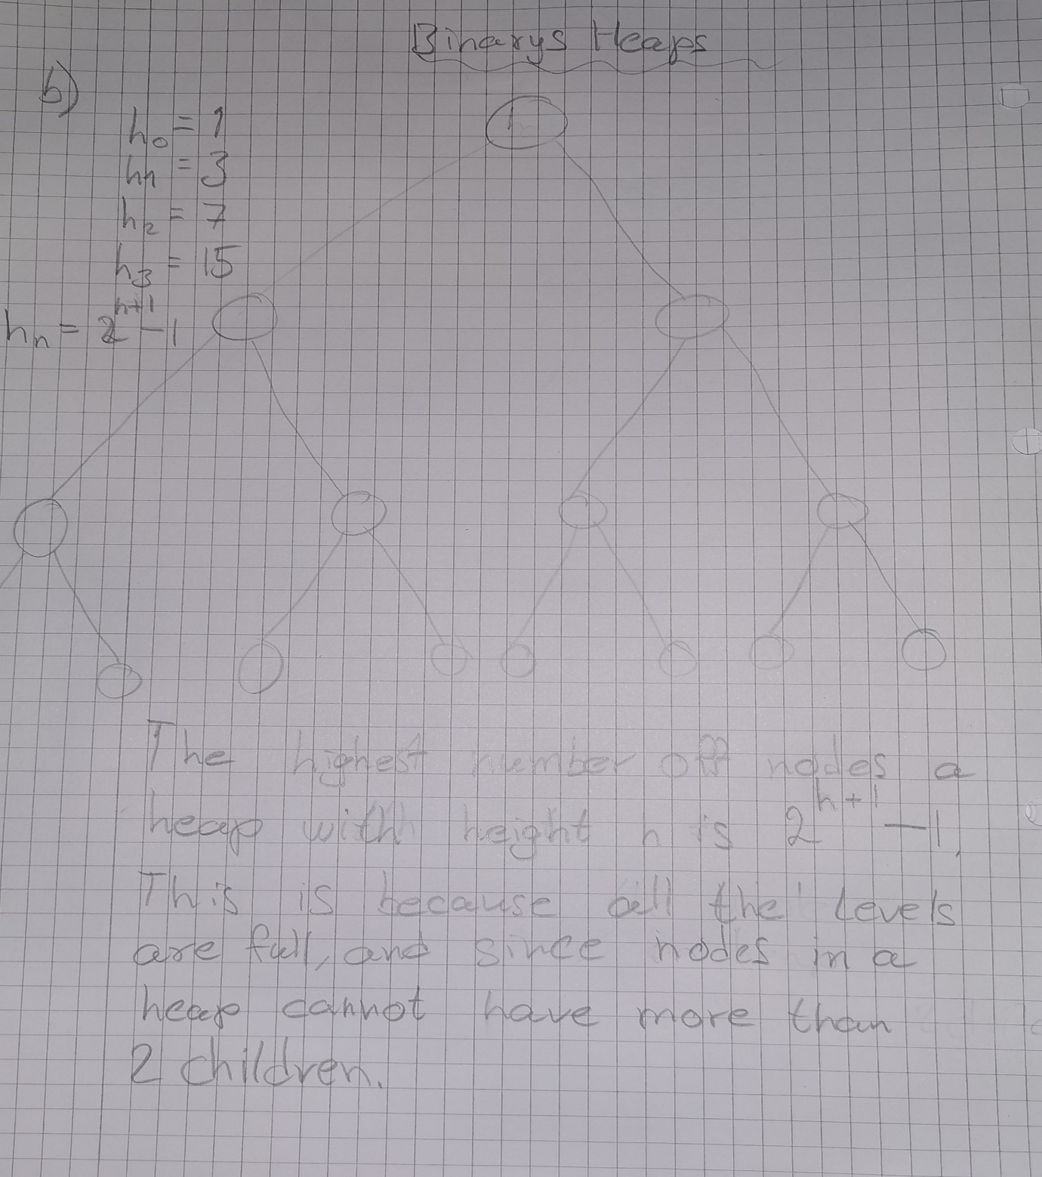

The highest number of nodes a heap with height h is . This is because all the levels are full, since nodes in a heap cannot have more than 2 children.